Jurnal Ilmu Administrasi
Vol. xx No.x
pp x-xx © 20xx
ISSN 1829 - 8974
e-ISSN 2614-2597
Media Pengembangan Ilmu dan Praktek Administrasi
Volume xx | Nomor x| Juni 20xx
TOURISM POLICY: POTENTIAL INCREASE OF ORIGINAL LOCAL INCOME

¹ Mila Karmila, ² Ikeu Kania
¹Fisip Universitas Garut
²Fisip Universitas Garut
¹milakarmila14@fisip.uniga.ac.id, ²ikeukania@fisip.uniga.ac.id

INFORMASI ARTIKEL |  | Abstract
Article history :  Dikirim :  xx-xx-20xx  Revisi Pertama :  xx-xx-xxxx  Diterima :  xx-xx-xxxx |  | Garut Regency called "Swiss van Java" has very beautiful natural scenery. This rich natural resource potency has not been the largest contributor to local original income. The poor implementation of tourism policy, particularly in exploring, inventorying, and developing tourist objects existing as the main attraction to tourists is one of its causal factor. The objective of research was to find out the effect of tourism policy implementation to local original income in Garut Regency. The research method employed was quantitative one; data collection was carried out by distributing questionnaire to 130 respondents. The data collected was then analyzed using simple regression data analysis with SPSS 23 help. The result of research showed that the implementation of tourism policy measured using standard and target, resource, inter-organization communication, executing organization characteristic, executive’s attitude, and social, economic, and political environment dimensions contributed to local original income by 38%.
Kata Kunci :
petunjuk penulisan; jurnal administrasi; template artikel

Keywords :
Policy Implementation; Tourism Policy; Local Tourism Development

- INTRODUCTION
As one of state’s income sources, tourism sector is very potential to develop. Tourism is considered as a multidimensional activity in development pertaining to social-cultural, economic, and political aspects (Spillane, 1987). As stated in Law Number 9 of 1990 about Tourism, government contributes to tourism planning and development as legislator and regulator. In addition, the government is also responsible for deciding the destination in tour travel.

Tourism is a travel from one place to another that is provisional in nature, conducted either individually or in group, as an attempt of looking for balance or harmony and happiness with living environment in social, cultural, natural, and science dimensions (Spillane, 1987) . Tourism is also traveling to satisfy the passion and the curiosity on the pleasure-related interest (Masruroh & Nurhayati, 2016).

Garut Regency is the regency very rich of tourist destinations, including natural, cultural, religious, and culinary. Therefore, the policy existing should be the reference for the tourism management to run well in Garut Regency.

Meanwhile, the tourism-related policy in Garut Regency is mentioned in Garut Regency’s Local Regulation of Number 2 of 2019 about Master plan of Local Tourism Development in 2019-2025 stating that the vision of Regency’s local tourism development is the realization of Regency area as the natural-based superior tourist destination in West Java with cultural support that is competitive and sustainable, toward pious, advanced, and prosperous community.

The policy implementation model formulated by (Grindle, 1980) is called Implementation as A Political and Administrative Process. Grindle said that there are two variables affecting the policy implementation: content of policy and context of implementation. The content of policy consists of: interests affecting, type of benefit, degree of change to be achieved, location of decision making, program implementation, and human resource. In the same vein, (Edward III, 1980) suggested that Policy implementation, as we have seen, is the stage of policy making between the establishment of a policy and the consequences of the policy for the whom it affects”.

The policy implementation model formulated by (Metter, V., & Horn, 1975) is called A Model of The Policy Implementation; this model is used to analyze the implementation of policy. The components of model are as follows: 1) Standard and Target of Policy, 2) Policy Resource, 3) inter-organizational communication and implementing activity, 4) characteristics of implementing agent, 5) economic, social, and political environment condition, and 6) Implementers’ Attitude.

In relation to tourist destination, many visitors coming from outside town to Garut Regency is important factor to observe closely. In the presence of various tourist destinations, Garut Regency’s local government should prepare itself for being competitive tourist destination, one of which is through creating credible tourism product, thereby can contribute foreign exchange to national tourism and spur the local tourism business to be important element in the attempt of improving community economy and Original Local Income (PAD).

Good policy is expected to improve a substantial PAD potency in tourism sector in Garut Regency. Government realizes that tourism sector is not the largest contributor to local income, but potentially increases Original Income (PAD) (Yuningsih, 2005). This tourism’s contribution can be indirect income or indirect impact on non-tourism life growing due to tourism activity (Imron, 2015).

Original Local Income is the source of local income made as a means of running government wheel, development, service and society, in addition a means of achieving the improved people wellbeing (Hardianti & Hasyim, 2016).

In addition, as tourist destination city, Garut Regency should provide good service to tourists. Souvenir centers are required to facilitate the tourist getting souvenirs they want, and so are culinary centers. The facilities should be unnecessarily luxurious, but they should be organized tidily and clean, to attract the tourist visits. With the existing potency in Garut Regency, it has been appropriate for the Local Government of Garut Regency to attempt to improve the people welfare from tourism and trading sector, in addition to farming, plantation, and animal husbandry, and small industry existing. Those sectors will support each other and create new job opportunity to the people. To improve the people welfare and to optimize potential tourism and trade in Garut Regency, comparative study should be conducted on those engaged directly in the problems.
Tourism sector management essentially can help Garut Regency’s economy. However, in fact based on the author’s prior observation on the implementation of tourism policy in Garut Regency, the tourism policy has not been implemented comprehensively. It can be seen from Human Resource’s poor understanding on tourism policy, so that the preparedness of local tourist destinations has not distributed evenly yet. In addition, the target of local tourism policy still focuses on some tourist objects only. For example, Special Allocation Fund of IDR 5 billions was focused only on the construction of Situ Bagendit, Cangkuang, and Sayang Heulang tourist objects only, so that other tourist objects did not get construction fund allocation. Meanwhile, tourist objects managed by DISPARBUD, consisting of 5 objects, have not been developed maximally yet in order to be competitive at provincial and national levels. Another problem arising is related to Third Party, in which investor as the capital owners very rarely consult with BAPPEDA and BPMPT in developing tourism business, so that it is incompatible to RIPPDA and RTRW. For example, many investors have constructed tourist object but have not reported yet to Integrated Investment and Licensing Office, so that the construction is sometimes incompatible to RIPPDA and RTRW, thereby is considered as problematic.

The less optimum economy in tourism sector can be seen from not-too much Original Local Income (PAD) coming from tourism sector in Garut Regency and economic development still concentrated on some tourism areas only. The income of tourism sector managed by DISPARBUD includes inn/lodge/villa and retribution of recreation and sport center business service. The target and the realization of Original Local Income from tourist object managed by Tourism and Cultural Office of Garut Regency are summarized in Table 1.

Table 1 Target and Realization of Original Local Income of Garut Regency’s Tourism and Cultural Office

No | Tahun | Tempat penginapan/villa |  |  | Retribusi Jasa Usaha Tempat Rekreasi
No | Tahun | Target | Realisasi | Persentase | Target | Realisasi | Persentase
1. | 2014 | 1.692.500.000 | 1.481.243.000 | 87,52% | 307.500.000 | 300.024.000 | 97,56%
2. | 2015 | 1.910.975.000 | 1.393.334.000 | 72,91% | 329.075.000 | 342.572.000 | 104,1%
3. | 2016 | 1.637.438.940 | 1.570.380.000 | 95,90% | 351.727.725 | 469.446.000 | 133,4%
4. | 2017 | 1.549.500.000 | 11.258.724.000 | 174% | 650.000.000 | 678.725.500 | 104,4%
5. | 2018 | 1.825.624.054 | 727.318.000 | 39,83% | 625.048.491 | 662.958.500 | 106%
Source: Tourism and Cultural Office of Garut Regency, 2019

From table above, it can be seen that the target and the realization of PAD from tourism sector managed by DISPARBUD decreased dramatically from 2017 to 2018, but it increased substantially from 2016 to 2017. Meanwhile, if the revenue coming from tourism sector is managed well by DISPARBUD, it will contribute substantially to PAD. In addition, tourism sector can absorb substantial number of workers, and thereby can minimize the unemployment rate in Garut Regency.

Recalling that Garut Regency has many potential tourist attractions, the management of tourism sector is required to improve local income. It is in line with the objective of Law No. 32 of 2004 related to local autonomy, to enable the region to control and to explore financial sources easily, particularly Original Local Income (PAD), to fulfill the government for financing and development in its own region.

Considering the problem phenomenon elaborated in background section, the author is interested in conducting study and studying more in-depth the tourism policy and the original local income as revealed in the problem phenomenon through a research entitled “Tourism Policy: Potential Increase of Original Local Income”. The objective of research was to find out the effect of tourism policy on Original Local Income (PAD) of Garut Regency.

- METODE / METHOD

The method employed in this research was quantitative research one. The measuring instrument used in data collection was structured questionnaire. The respondents of research consisted of 130 persons. Data collected was then analyzed using statistic descriptive method and statistic differential methods with simple regression analysis. Regression was used when the author wants to predict the result of certain variables using other variables, involving two variables: independent and dependent variables.

- HASIL DAN PEMBAHASAN / RESEARCH FINDING AND DISCUSSION
The research conducted by author aims to find out the Tourism Policy: Potential Increase of Original Local Income. The result of data processing on Tourism Policy: Potential Increase of Original Local Income is presented as follows.
4.1. Classical Assumption Test
Simple regression test can be conducted following the classical assumption test to find out whether or not the data to be used is free of classical assumption in which data does not contain normality, autocorrelation, and heteroscedasticity. The result of data processing using SPSS 23 is presented below:
a. Normality Test
Normality test is a test conducted on a group of data to find out whether or not data distribution forms normal curve. The good model has normal or close-to-normal distribution. This assumption test was conducted by seeing normal P-P plot of regression standardized residual through regression calculation with Statistic Package For Social Science (SPSS) 23 program. The easiest way to see normality is to see historiogram or display of graphic indicating certain distribution pattern. The decision making is conducted based on the following:
- If data is distributed around diagonal line and following diagonal line direction, regression model complies with normality assumption
- If data is distributed far from diagonal line or not following line direction, regression model does not comply normality assumption
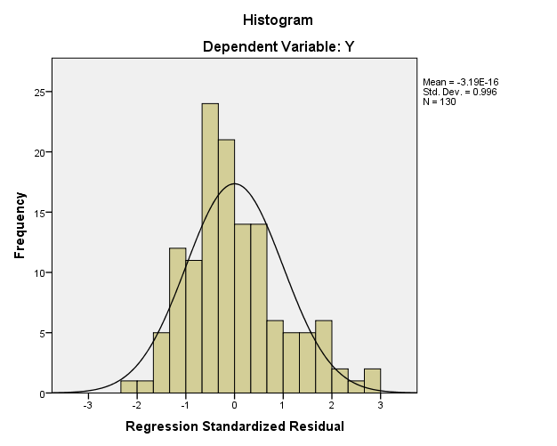
Figure 1 Histogram
From histogram graphic in Figure 1, it can be explained that the graphic is bell-shaped; thus, it can be concluded that regression model is distributed normally as it has met normality assumption. Thus, assumption that the data is distributed normally is met, and the distribution of original local income variable data (Y) has normal value.
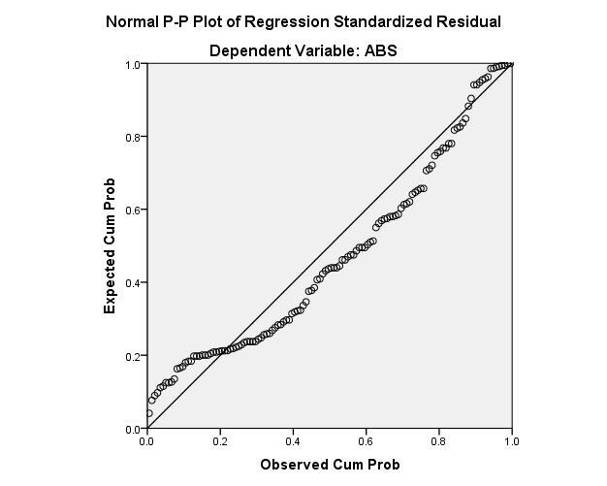
Figure 2 Graphic of Normal Probability Plot

From the graphic of normal probability plot shown in Figure 2, it can be explained that data is distributed around diagonal line and following diagonal line direction. As such, it can be concluded that in this research, the regression model is distributed normally as it has met the assumption of normality.

b. Heteroscedasticity Test
Heteroskedasticity Test aims to examine whether or not there is a permanent difference of residual variances between on observation and another. The good regression model does not show heteroscedasticity occurring; the method used in this test is through analyzing the graphic of regression plot between dependent variable prediction value (ZPRED) and its residual (SRESID).

The detection of heteroscedasticity can be conducted by seeing whether or not there is certain pattern in scatter plot graphic between SRESID and ZPRED in which Y axis is the predicted one and X axis is residual (predicted Y – actual Y) that has been studentized. The assumption of heteroscedasticity can be analyzed as follows:
- If there is a certain pattern, such as the existing points creating a certain regular pattern (waving, widening and then narrowing), heteroscedasticity has occurred.
- If there is no clear pattern, and point distributed above and below 0 (zero) number on Y axis, no heteroscedastisity occurs.
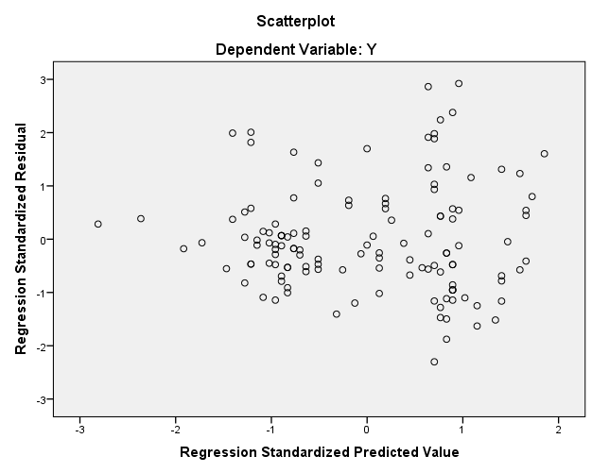
Figure 3 Scatterplot
From Figure 3 showing scatterplot, it can be seen that the plot is distributed randomly above and below zero number on regression studentized residual axis; therefore it can be said that no heteroscedasticity problem occurs in this model.
c. Autocorrelation Test

Table 2 Model Summary

Model | R | R Square | Adjusted R Square | Std. Error of the Estimate | Change Statistics |  |  |  |  | Durbin-Watson
 |  |  |  |  | R Square Change | F Change | df1 | df2 | Sig. F Change | Durbin-Watson
1 | .62ª | .38 | .110 | 6.26024 | .117 | 16.982 | 1 | 128 | .000 | 1.984
a. Predictors: (Constant), X
b. Dependent Variable: ABS

From the table (appendix), it can be seen Durbin-Watson value of 1.984. This value is compared with table value using significance value of 5%, sample size of 30 and 1 independent variable. Therefore, Durbin-Watson value of 1.984 is higher than upper margin (du) and lower than 4-du; it can be concluded that there is no autocorrelation.

4.2. Simple regression test
Considering the result of regression analysis and using significance level of 5%, the following equation is obtained.
Y = 39.516 + 0.276 PAD
From the result of regression, it can be concluded that: Regression Coefficient value of 0.276 indicates that each 1% increase in Original Local Income will increase tourism policy by 39.5%.

4.3. Coefficient of Determinacy Analysis
The coefficient of determinacy calculation is used to indicate the closeness coefficient of determinacy, constituting the quadrate of correlational coefficient. Coefficient of determinacy is also called determinant coefficient because the variance occurring in dependent variable can be explained through independent variable. Coefficient of determinacy can be calculated using the following formula:
KD = r2 x 100%
KD = 0.622 x 100%
KD = 38.44%

The result of test shows that the coefficient of determinacy value is 0.38. It means that only 38% original local income can be affected by tourism policy variable, while the rest of 62% is affected by other independent variables.

Considering the data shown in the result of research above, it can be concluded that tourism policy on the potential increase of original local income will yield sufficiently significant result. The elements of tourism policy includes standard and target, resource, inter-organizational communication, organizational characteristic implementer, executive attitude, and social, economic, and political environment dimensions highly affect the potential increase of original local income.

4.4. Result of Hypothesis Testing
The result of hypothesis testing is one thing compulsory in statistic. The most important stage of statistic analysis that cannot be missed is hypothesis testing. This hypothesis testing is conducted as a statistically authentication of the presence of positive effect of tourism income on the growth of original local income. This statistic hypothesis testing is conducted using t-statistic test. This statistic hypothesis from the hypothesis testing in this research can be written as follows:
H0 : There is no positive effect of tourism policy on original local income.
H1 : There is no positive effect of tourism policy on original local income.
From the calculation above, it can be found t-statistic value of 1.9788 and t-table is 4.121. It means that t statistic 1.9788< t table 4.121, meaning that H0 is not supported and H1 is supported; therefore, hypothesis testing indicates that there is a significant effect of tourism policy on original local income.

- CONCLUSION AND RECOMMENDATION

Considering the result of description of each variable above, it can be concluded that tourism policy measured using standard and target, resource, inter-organization communication, organization characteristic implementer, executive attitude, and social, economic, and political environment dimensions affect the original local income positively and significantly. Therefore, it can be said that the original local income will increase when tourism policy can support it.

REFERENCE
Edward III, G. C. (1980). Implementing Public Policy. Congressional Quarterly Press.
Fitri, D. (2014). Pengaruh Sektor Pariwisata terhadap Pendapatan Asli Daerah di Kabupaten Pesisir Selatan. Sekolah Tinggi Keguruan Dan Ilmu Pendidikan, 4(2), 4–14.
Grindle, M. S. (1980). Politics and Policy Implementation in The Third World. Princeton University Press.
Hardianti, W., & Hasyim, S. Bin. (2016). Pengaruh Kualitas Pelayanan jasa Angkutan umum terhadap PAD di Sub Terminal Limbangan Kabupaten Garut. Jurnal Pembangunan Dan Kebijakan Publik, 7(1).
Hardianto, W. T., Yolanda, F. A., & Adiwidjaja, I. (2020). Upaya pemerintah daerah dalam pengembangan potensi pariwisata. Jurnal Inovasi Ilmu Sosial Dan Politik, 2(2), 188–195.
Hendrita, V. (2017). Kebijakan Pengembangan Pariwisata Di Kabupaten Tanah Datar. Agrifo : Jurnal Agribisnis Universitas Malikussaleh, 2(2), 73. https://doi.org/10.29103/ag.v2i2.379
Imron, M. (2015). Meretas Jalan Meningkatkan Pendapatan Asli Daerah (PAD) Melalui Desa Wisata Panglipuran Bali. Jurnal Bina Praja, 07(04), 279–288. https://doi.org/10.21787/jbp.07.2015.279-288
Masruroh, R., & Nurhayati, N. (2016). Strategi Pengembangan Pariwisata dalam Rangka Peningkatan Pendapatan Asli Daerah di Kabupaten Kuningan. Prosiding Seminar Nasional IPTEK Terapan (SENIT) 2016 Pengembangan Sumber Daya Lokal Berbasis IPTEK, 1(1), 124–133. https://ejournal.poltektegal.ac.id/index.php/prosiding/article/view/369
Metter, V., & Horn, V. (1975). The Policy Implementation Process : A Conceptual Framework. Departement of Political Science Ohio State University Administration and Society, 6(4).
Pradikta, A. (2013). Strategi Pengembangan Obyek Wisata Waduk Gunungrowo Indah dalam Upaya Meningkatkan Pendapatan Asli Daerah (PAD) Kabupaten Pati (Doctoral dissertation. Universitas Negeri Samarang.
Spillane, J. J. (1987). Pariwisata Indonesia Sejarah, dan Prospeknya. Kanisius.
Suardana, I. (2016). Analisis Kebijakan Pengembangan Pariwisata. Seminar Nasional Pariwisata Berlanjutan, April.
Sugara, D. B., & Winarso, W. (2013). Pengaruh Pendapatan Pariwisata Terhadap Pendapatan Asli Daerah Di Kabupaten Garut. Jurnal Ekonomi, 1(2), 1–6. https://doi.org/https://doi.org/10.31311/jeco.v1i2.127
Wulandari, P. A. (2016). Analisis Pengaruh Kontribusi Pajak Daerah Terhadap Pendapatan Asli Daerah (PAD) Kota Banjarmasin. Prosiding Seminar Nasional INDOCOMPAC, 377–394.
Yuningsih, N. (2005). Peningkatan Pendapatan Asli Daerah (PAD) Melalui Pengembangan Potensi Obyek Wisata. Universitas Negeri Samarang.

